What is Combination?
A combination is a selection of objects from a larger group where the order of selection does not matter.
For example, there are 3 components – A, B and C. The combination of any two letter out of three letters A, B and C is shown below –
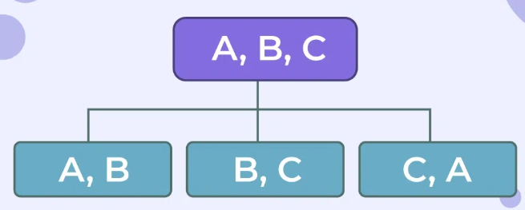
Formula
The number of ways to choose r items from a total of n items is written as ^{n}C_{r} or C(n, r).
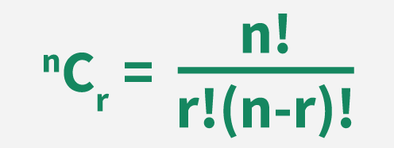

Example
A class has 5 students. We need to select a team of 2 students for a project.
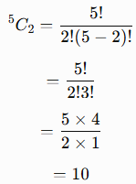
Therefore, there are 10 possible teams.
Questions
1) Find the number of ways to select 3 books from 5 different books on the shelf. n = 5, r = 3 ⁵C₃ = 10
2) Rahul has to choose 5 marbles from 12 different colored marbles. In how many ways can she choose them? n = 12, r = 5, ¹²C₅ = 12!/(5!7!) = 11 x 9 x 8 = 99 x 8 = 792
3) Jayesh asks his daughter to choose 4 pens from the basket. If the basket has 18 different pens to choose from, how many different possible ways she can do it? => n = 18, r = 4 => ¹⁸C₄ = 18! / (4!14!) = 3 x 17 x 4 x 15 = 51 x 60 = 3060
4) How many ways can you pick a team of 3 people from a group of 10 people? => n = 10, r = 3 => ¹⁰C₃ = 10! / (3!7!) = 10 x 3 x 4 = 120
5) You want to pick 2 different toppings for a pizza from a menu of 5 choices. In how many ways, it can be done? => ⁵C₂ = 10
6) How many ways can you draw a hand of 5 cards from a standard deck of 52 cards? ⁵²C₅ = 52! / (5! 47!) = 52 x 51 x 5 x 49 x 4 =
7) Suppose you have the digits: 1, 2, 3, 4, 5, 6. In how many ways any 3 digits can be selected without repetition? ⁶C₃ = 6! / (3! 3!) = 5 x 4 = 20
8) How many bit strings of length 6 contain exactly four 1s? ⁶C₄ = 6! / (4! 2!) = 3 x 5 = 15
9) How many bit strings of length 8 contain exactly two 1s?
10) A binary message consists of 10 bits. Exactly 4 bits must be 1 and the remaining 6 bits must be 0. How many different messages are possible?

Combinations with Repetitions
When we select r objects from n different types, and the same type can be selected more than once, we use the formula:
Examples:
1) A shop has 3 types of fruits: Apple, Banana and Orange. You want to select 4 fruits, and you can select the same fruit more than once. In how many ways you can select? => n = 3, r = 4 => ³⁺⁴⁻¹C₄ = ⁶C₄ = 6! / (4! 2!) = 6 x 5 / 2 = 15
2) There are 4 flavours of ice cream. A customer wants 3 scoops, and the same flavour can be selected more than once. How many different ways are possible? => n = 4, r = 3 => ⁴⁺³⁻¹C₃ = ⁶C₃ = 6! / (3! 3!) = 6 x 5 x 4 / 3 x 2 = 20
3) A bit string contains 0s and 1s. How many ways can we select 5 bits if repetition is allowed and order is ignored? => n = 2, r = 5 => ²⁺⁵⁻¹C₅ = 6
0 0 0 0 0
1 1 1 1 1
0 1 1 1 1
1 0 0 0 0
0 0 1 1 1
1 1 0 0 0
4) You are ordering a bowl with 4 scoops of ice cream, and there are 5 different flavors available (Chocolate, Vanilla, Strawberry, Mint, and Mango). You are allowed to repeat flavors and the order of scoops doesn't matter. How many different ice cream combinations can you make? => n = 5, r = 4
5) A bakery sells 3 types of donuts: Glazed, Chocolate, and Jelly. In how many ways can you choose a box of 6 donuts if repetition of types is allowed and the order in which they are placed in the box doesn't matter?

